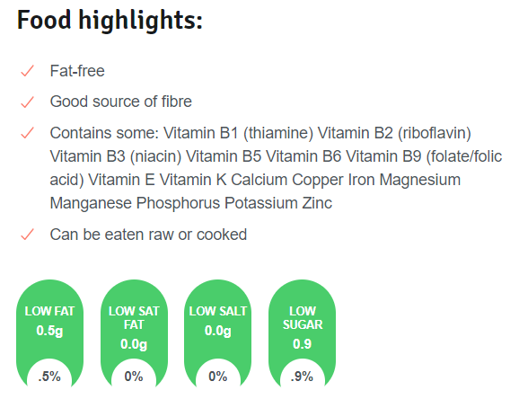

**Why coriander is good to eat**

* Coriander is a good source of vitamins A (important for growth and development and the maintenance of your immune system), C (needed for the growth and repair of tissues in the body) and K (important for helping your blood to clot).
* It also contains minerals such as potassium (which helps to regulate blood pressure), manganese (involved in the regulation of brain and nerve function) and magnesium (involved in the regulation of muscle, heart and nerve function and keeping bones strong).
* Coriander contains dietary fibre, which is important for a healthy bowel.
* Energy – 100 g of coriander supplies 95 kJ.